Sow Sweet peas

‘To plant a garden is to believe in tomorrow’ – Aubrey Hepburn.


I think we all need some hope at the moment, these are really easy to grow, take little attention but will give you plumes of gorgeous scented and colorful flowers come summer.

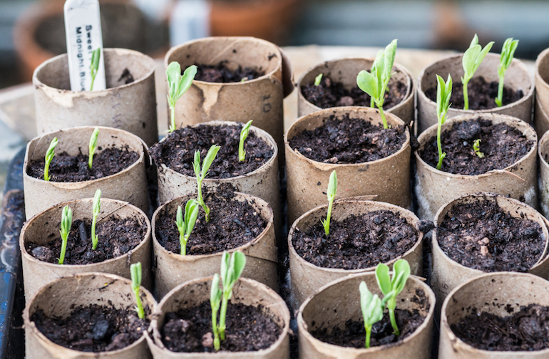
You can find sweet pea seeds in your local supermarket or garden centre or you can order online.

Method
The packet should give you all the instructions you need but I like to:
- Soak the seed for a couple of hours. This softens the seed shell and encourages growth.
- Plant in 9cm pots or similar. Sweet peas have long roots so its best to plant them straight into pots so they have lots of room. If you don’t have pots you can use toilet rolls as great substitutes.
- Plant them 2 seeds to a pot
- Use good quality compost to give them a good start
- Leave them inside on a bright windowsill or kitchen counter, keep the soil moist.
- They should germinate inside between 7-10 days, once they have sprouted you can put them outside, in a sheltered, sunny position or ideally in a greenhouse.
- Plant out in May when the last frost has passed and wait for the lovely flowers to bloom in Summer.


You should have plenty of sweet peas if you buy a packet of seeds. So why not grow some and give them away #createalittlelove and brighten someone elses day.

