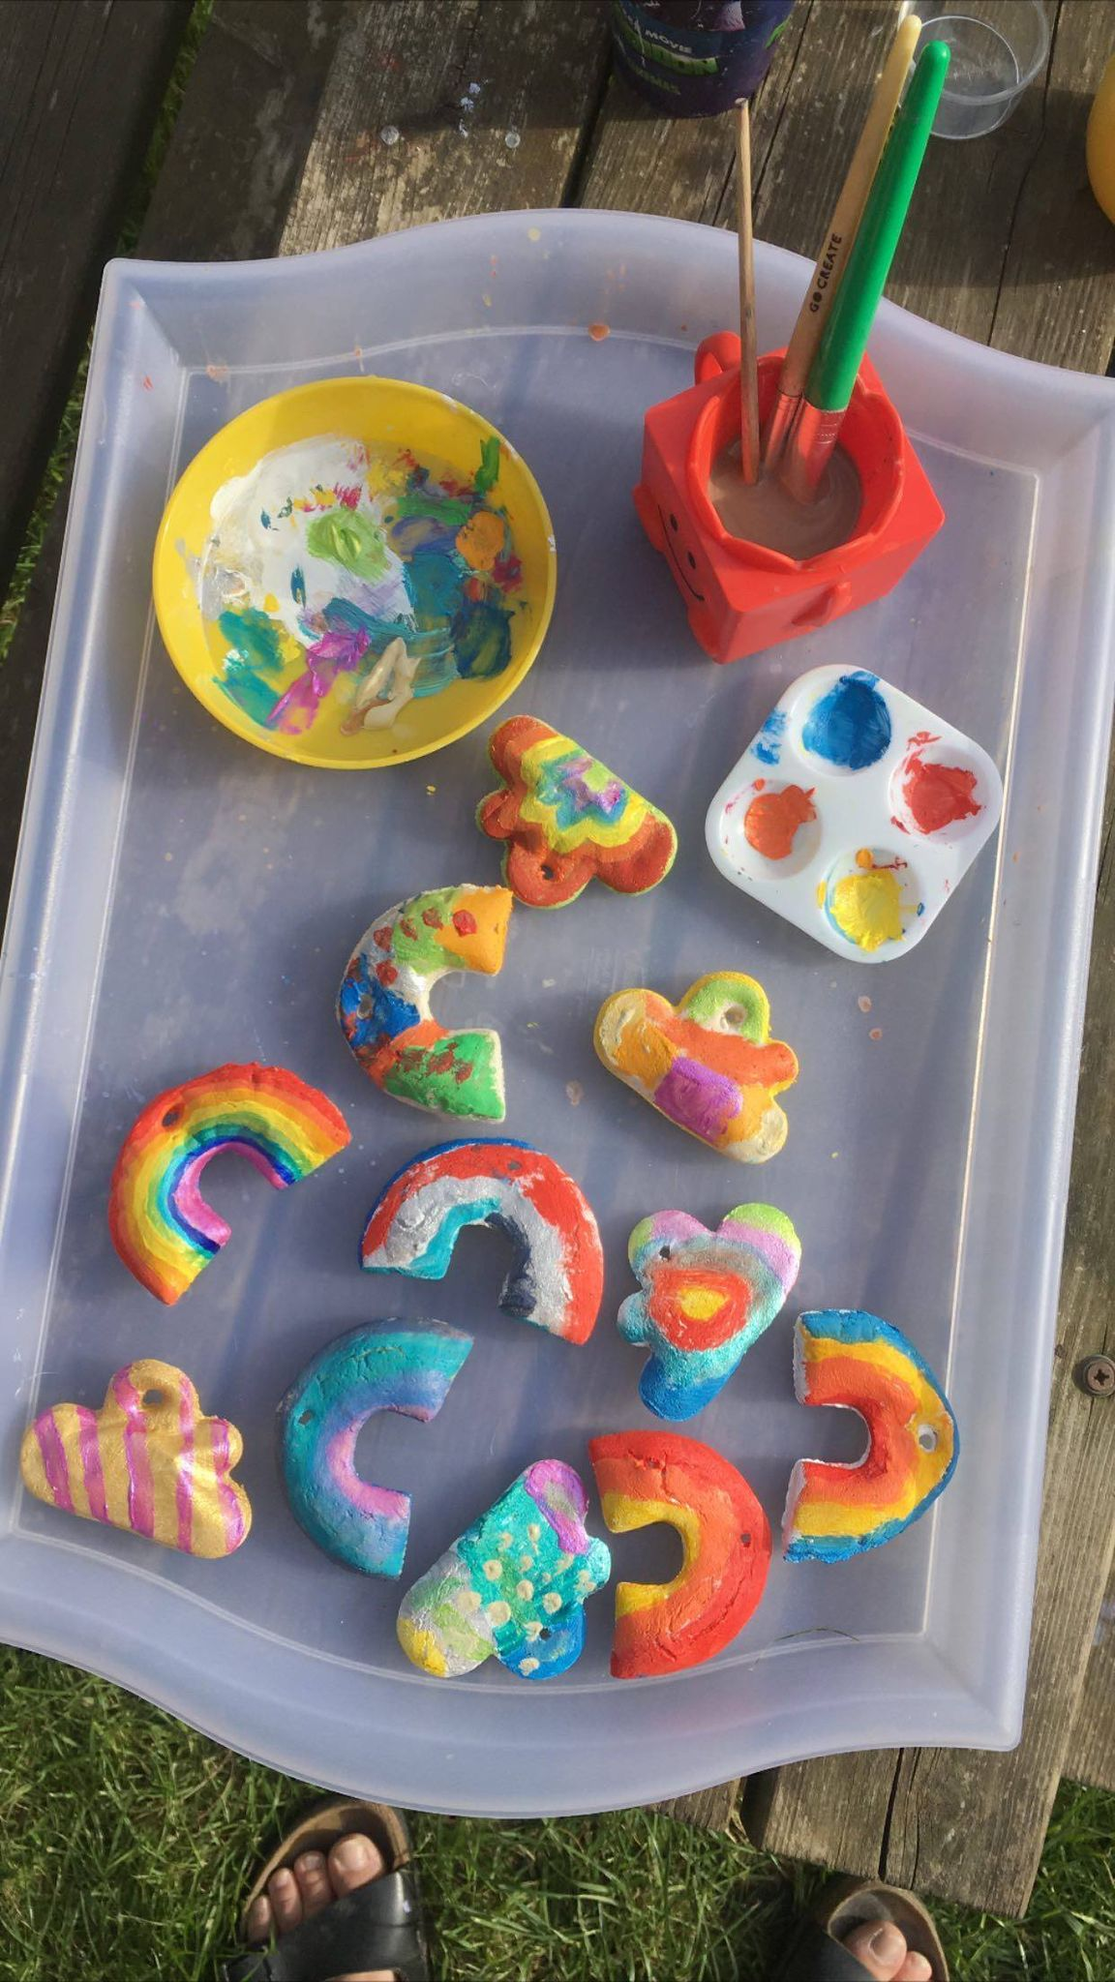
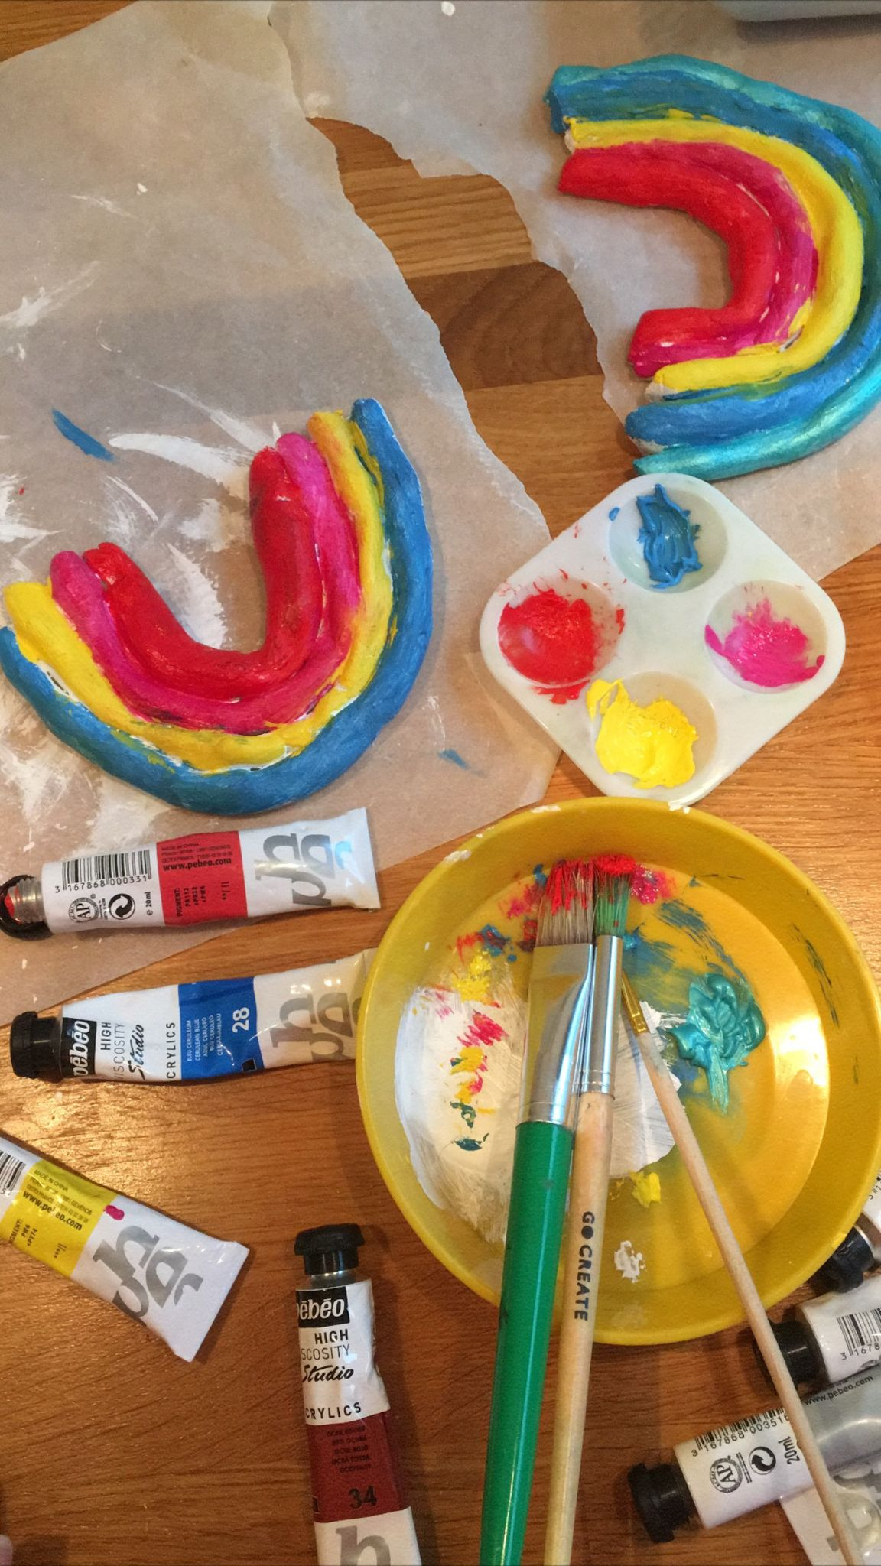
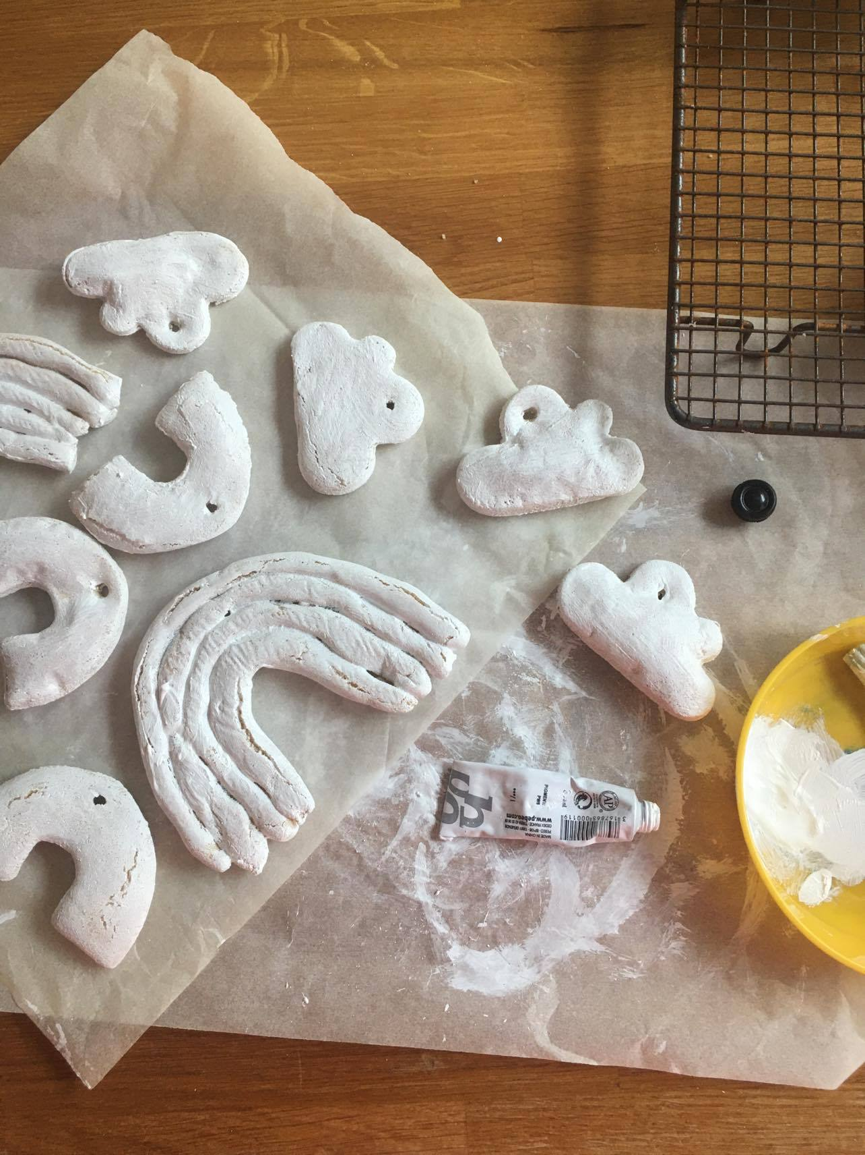
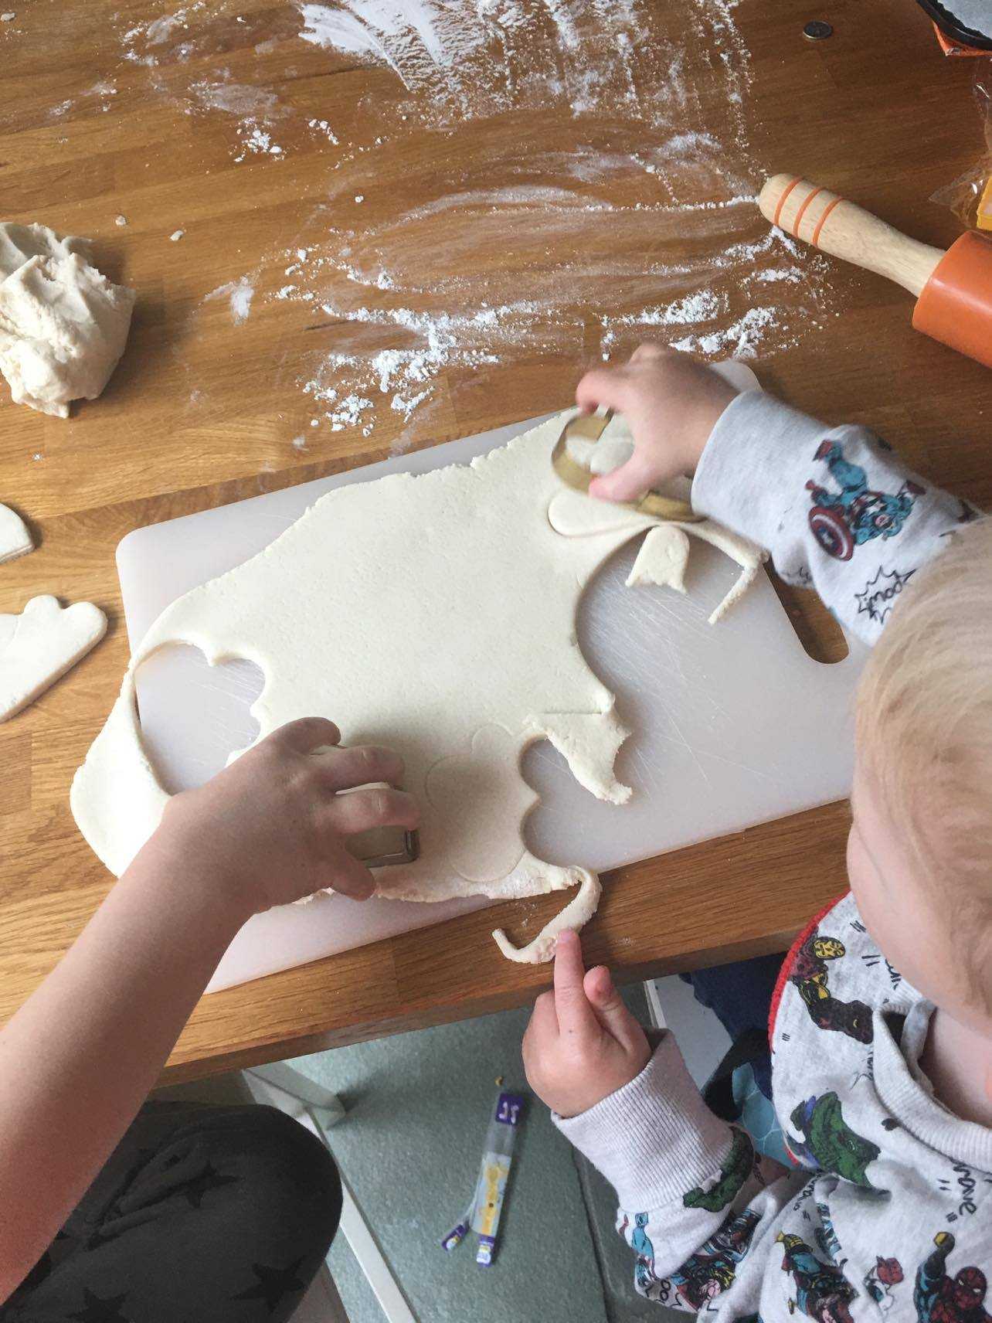
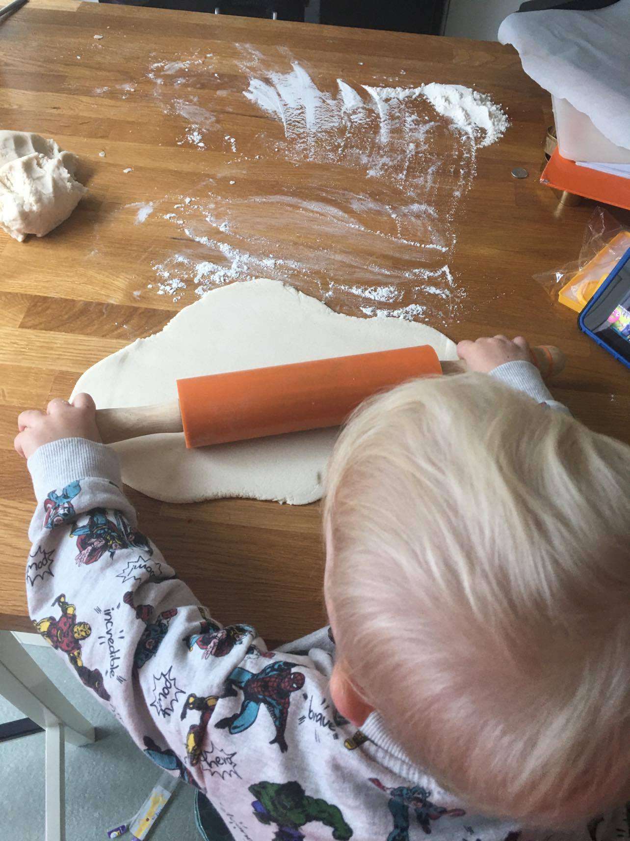
Salt Dough Decorations

Ingredients for the Salt Dough
- 2 cups flour
- 1 cup salt
- 1 cup water

Method
- Mix all the ingredients together until it comes together into a ball
- Transfer the dough onto a floured work surface
- Then shape your decorations. We used cookie cutters but also made bigger rainbows by rolling out strips into snake like shapes and then gently pressing them back into the shape of the rainbow. You can also use a little bit of water to make sure they stick together
- If you would like to hang the decorations make sure to put a little hole in now for the ribbon
- Bake in the oven on greaseproof paper for around 3 hours on the lowest setting
- Leave to dry out over night.

Decorating
- I white washed the decorations first so the paints colour was really bright when decorated. Use acrylic paints to paint
- You can also add more decorations such as glitter, feathers, just wait for paint to dry and use PVA glue.
