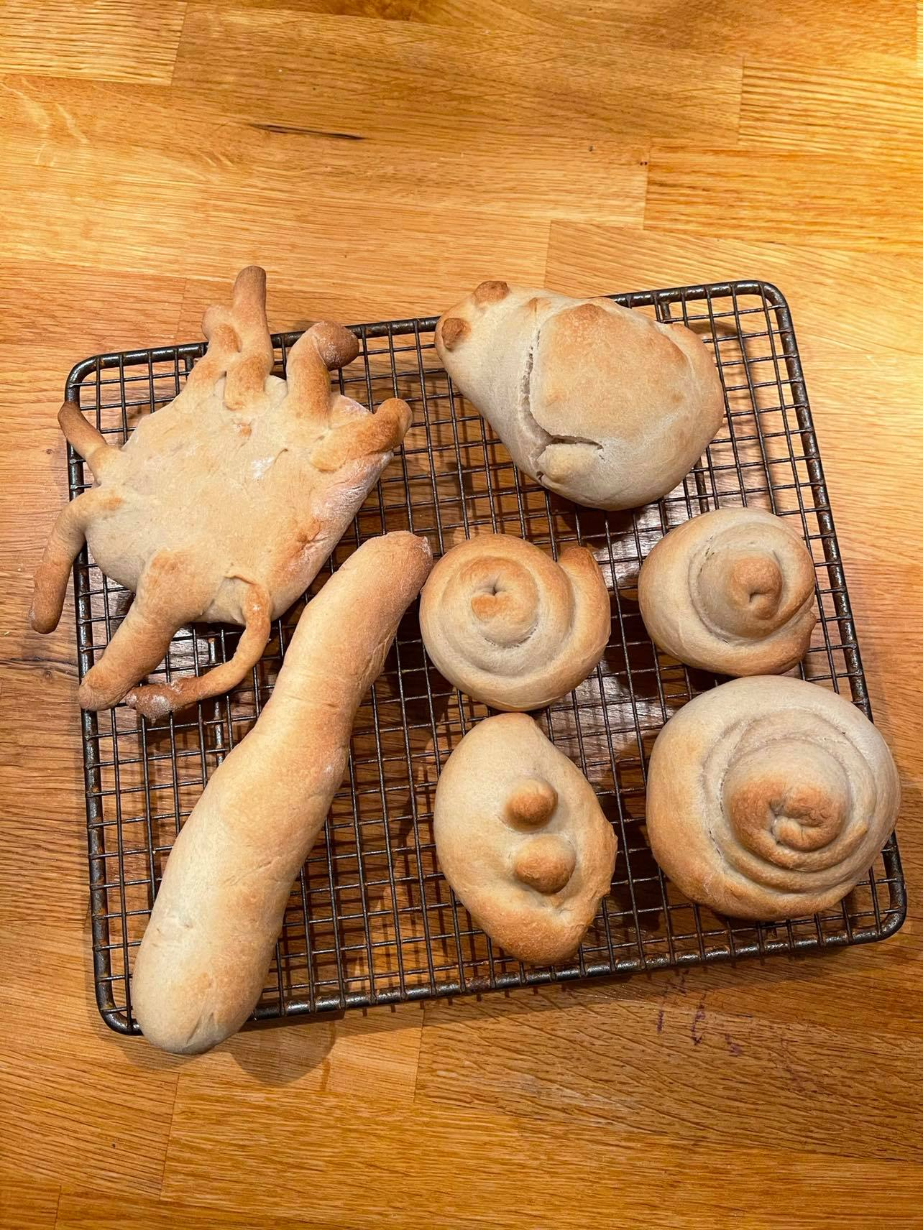
Bread Roll Animals

Recipe
- 3 ½ cups flour, plus more for kneading and shaping.
- 1 teaspoon of salt
- ½ cup warm water
- 1 tsp granulated sugar
- 2 ¼ teaspoon of instant or active dry yeast
- 1 large Egg
- ¾ Cup Warm Milk
- ¼ cup unsalted butter

Method
- Dissolve yeast and sugar in lukewarm water. Let sit until foamy
- Add egg and lukewarm milk. Stir to combine slightly
- Add half of flour along with salt. Mix everything together until you get a thick and sticky dough.
- Add butter along with remaining flour. Knead for 5- 10 minutes, adding flour as needed, or until you have a smooth ball of dough that’s not too sticky.
- Kneed for around 10 minutes until smooth and springy
- Cover the dough. Set aside for 45 minutes to 1 hour, or until nearly doubled in size.
- Then get creative and design your animals!
- Bake in the oven for 25- 30 minutes at 180 degrees.

Why not make it social and organise a zoom bread making call, classmates, friends, grandparents, everyone will enjoy getting their hands doughy and attempting to win the best animal award! #createalittlelove.
