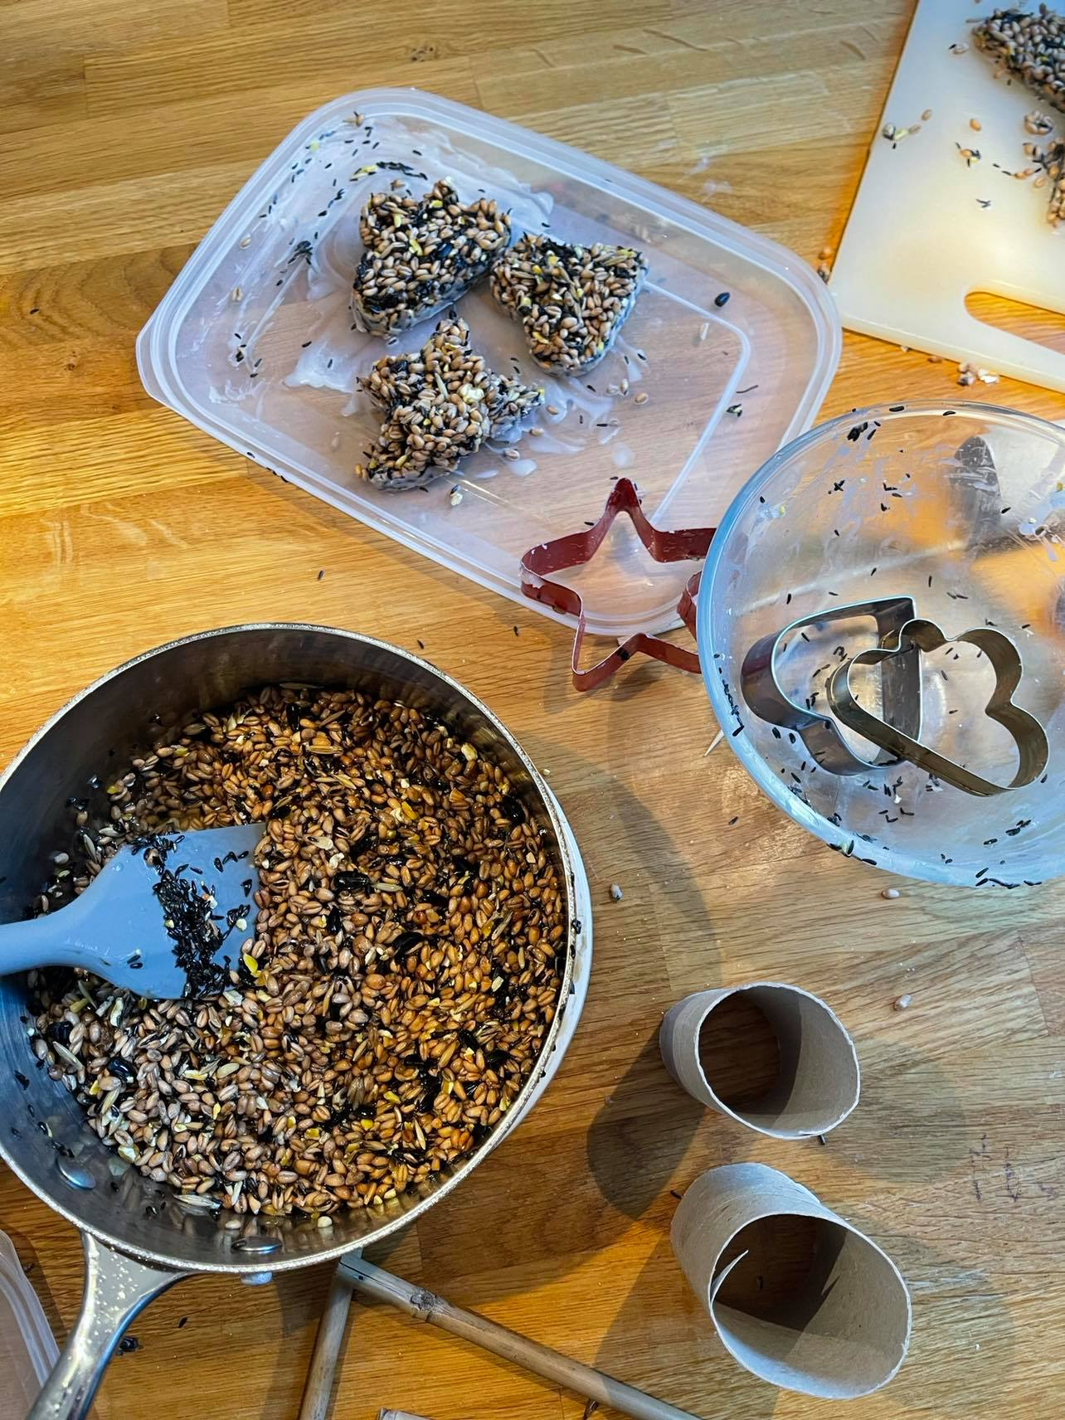
Birdseed Heart Feeders

Perfect pick me up for us and our little friends in the garden. This recipe makes lots so perfect to share with neighbours and friends #createalittlelove.

What you will need
- Lard
- Mixed Bird Seed
- Heart shaped cookie cutter
- Ribbon or string

How to make the bird feeder
1. Gently melt 100g of lard in a saucepan. Add 250g of bird seed, make sure all the seeds are coated.

2. Place the cookie cuter on a plate and fill with the seed mixture, press down and compact the seed lard mixture as much as possible, until packed tightly.

3. Put a small hole in the heart using a skewer or knife for your string. Don’t be to close to the edge as it may weaken the heart when hung.

4. Put in the fridge and leave over night to set.

5. Ease the heart out of the cutter, thread with ribbon and hang high in a tree for all the birds to enjoy a winter snack.

